**COLLEGE VOTING SYSTEM**

**ABSTRACT**

College voting System would have Candidate registration, document verification, auto-generated User ID and pass for candidate and Voters. Admin Login which will be handled by Election Commission. Candidate Login which will be handled By Candidate, Voters will get Unique ID and Password, using which they can vote for a Candidate only once per Election. Admin can enter the login and create candidate and voter details, once the voter ID has generated, they can login and vote to the candidate. The project is beneficial for Election Commission, Voters as the can get to know the candidate background and choose wisely, and even for Candidate. The software system allows the Candidate to login in to their profiles and upload all their details including their previous milestone onto the system.

The college voting system is highly developed and the college voting system can be replaced by accurately and directly voting and immediate results. The college voting system is done by the internet so it can be called the Internet Voting.

The main objective of this project is to maintain all the process involving in the election process for the college into online election process. It deals all the student details, Department Details, Posting Details, Nominee Details, Voting Process and Voting Result process.

The online voting system reduces the man power and time consumption required to conduct the voting process. Existing system requires more man power and it depends on the voter’s presence. Though the students having rights to cast their vote, if they are not in their place ie, if they leave for college their vote may not cast and it may be misused by some illegal persons.

**SYSTEM SPECIFICATION**

**HARDWARE SPECFICATION**

* Processor : P 4 700 GHz.
* RAM : 4 GB RAM
* Hard Disk Drive : 180 GB

**SOFTWARE SPECIFICATION**

* Operating System : Windows 7/8/10
* Front End : JAVA
* Back End : SQL

**MODULES**

**MODULES DESCRIPTION**

**Voter Registration**

Voters are created by admin, once voters are created, they will get unique username and password. The voters can able to login via this application and update his/her profile details. Voter can’t add themselves.

**Candidate Registration**

Candidates are created by admin, once candidates are created, they will be displayed in the voting screen. Those details will be displayed in the election result as well.

**Candidate & Voter Details:**

This module contains provide the all information about the voter’s and candidates. These values have been collected from the voter and candidate table.

**Pooling vote**

Voter can pool their vote in this module. Once voter pooling their vote can’t vote more than one time. Voter select his favorite voter and pooling their vote

**Election Result**

Election result will be declared after the election will completed. Which is the main module for finding the winner. Rank wise we can display the winner candidates

**Data Flow Diagram / USE Case Diagram**

**LEVEL 0**

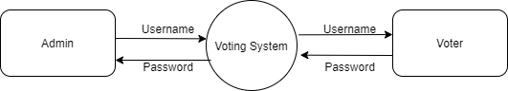

**Level 1**

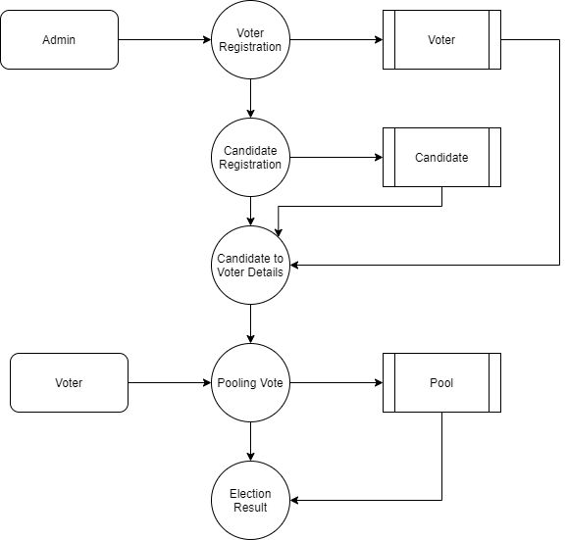

**ER Diagram**

